# GOVERNMENT POLYTECHNIC COLLEGE MATTANNUR-670702

### (Department of Technical Education, Kerala)



**SEMINAR REPORT ON**

**FLEXIBLE PHOTOVOLTAIC PANEL**

**SUBMITTED BY ABHINAV PRASANTH P T**

**(Reg.No:19041625)**

**DEPARTMENT OF ELECTRONICS ENGINEERING**

**2021-22**

**GOVERNMENT POLYTECHNIC COLLEGE MATTANNUR-670702**

**(Department of Technical Education, Kerala)**



**CERTIFICATE**

*Certified that seminar work entitled* “***FLEXIBLE PHOTOVOLTAIC PANEL*”***is a bonafide work carried out by* **“*ABHINAV PRASANTH P T*”** *in partial fulfilment for the award of Diploma in Electronics Engineering from Government Polytechnic College Mattannur during the academic year* 2021-2022.

### Seminar Co-ordinator Head of Section

**Internal Examiner External Examiner**

**DECLARATION**

I hereby declare that the report of *the* ***FLEXIBLE PHOTOVOLTAIC PANEL*** work entitled which is being submitted to the Govt. Polytechnic College Mattannur, in partial fulfilment of the requirement for the award **of *Diploma in Electronics Engineering*** *i*s a confide report of the work carried out by me. The material in this report has not been submitted to any institute for the award of any degree.

Place:Mattannur **ABHINAV PRASANTH P T**

### ACKNOWLEDGEMENT

I would like to take this opportunity to extend my sincere thanks to people who helped me to make this seminar possible. This seminar will be incomplete without mentioning all the people who helped me to make itreal.

Firstly, I would like to thank GOD, almighty, our supreme guide, for bestowing his blessings upon me in my entire endeavor.

I would like to express my deepest gratitude **Mr. M C PRAKASHAN** (Principal GPTC, Mattannur), **Mr. GEORGE KUTTY P P (**Head of Department of Electronics Engg.), for the help rendered by him to prepare and present this Seminar in proper way. Moreover I am very much indebted to **Mr. SREEJITH A** (Lecturer, Electronics Engg, seminar co-ordinator), for their advice.

I am also indebted to all my friends and classmates who have given valuable suggestion and encouragement.

**ABHINAV PRASANTH P T**

**ABSTRACT**

For the previous few decades, the photovoltaic (PV) market was dominated by silicon-based solar cells. However, it will transition to PV technology based on flexible solar cells recently because of increasing demand for devices with high flexibility, light weight, conformability, and bendability. In this review, flexible PVs based on silicone developed using the emerging technology are introduced. The technological limitations of traditional solar cells have been overcome, which will give rise to the new paradigm of solar energy conversion systems and flexible electronic devices. In this review, in terms of flexible PVs, we focus on the materials (substrate and electrode), cell processing techniques, and module fabrication for flexible solar cells beyond silicon.

TABLE OF CONTENTS

**CHAPTERNO TOPICS PAGENO**

Chapter1 INTRODUCTION……………………………………...8

Chapter2 GENERAL OVERVIEW………………………………10

Chapter3 PHOTOVOLTAIC TECHNOLOGY A REVIEW ...….11

Chapter4 CONCEPT OF PHOTO VOLTAIC..….. ………….….12

Chapter5 WORKING………..….……………………………..…13

Chapter6 MANUFACTURING PROCESS……………………...14

Chapter7 CLASSIFICATION………………………….………..15

Chapter8 RESEARCH AND DEVELOPMENT………………..16

Chapter8.1 FEATHER LIGHT SOLAR CELL…………..…….....16

Chapter8.2 SOLAR FABRICS….………………….………….…..16

Chapter9 ADVANTAGES AND DISADVANTAGES………....18

Chapter9.1 ADVANTAGES…………………………………….....18

Chapter9.2 DISADAVANTAGES………………….………….…..18

Chapter10 CONCLUSION………………………………………..19

Chapter11 REFERENCE………………………………………….20

|  |  |  |
| --- | --- | --- |
| **FIGURE NO** | **LIST OF FIGURES**  **NAME** | **PAGE NO** |
| Fig 4.1 | SCHEMATIC DIAGRAM OF ELEMENTAL PHOTOVOLTAIC SOLLAR CELL…….... | 12 |
| Fig 5.1 | CLASSIFICATION………………….……….. | 15 |

**CHAPTER 1**

**INTRODUCTION**

Mechanicall y flexible solar cells could drastically change the way energy is generated in the future.Son1e of the applications include use in high altitude and space enviromnents for teleco1nmu nication purposes, integrated cells for bu ilding energy, use as the pri1nary energy source in soft robotics, and even on clothing to charge a s1martphone.

To create a more flexible solat·cell there needs to be a co1npromise between thickness, mechanica l resilience, and durability. Efforts in advancing the technology of solai·cell dev ices have been prilnai·ily concerned with cost and efficiency of the cells. High device cost and prepai-ation requ u·ed to fabricate in orgatlic solar cells, which ai·e 1nost frequently used, have li1nited the ove1-all impact that solai·energy cai1 have.

The 1nost conunon inorganic solai·cell type is 1nade using crystallin e silicon as the semiconductor layer, which is separated into two layers of different types, positive and negative (p and n). The se1niconductor layer of this cell is sandwiched between a top cathode and botto 1n anode layer,

where the cathode has meta l connect ions placed onto it and the anode layer is attached to a metal contact , so that the cell can be wu·ed into a cu·cu it . This basic construction is constant for all 1najor cell types, il1clud ing CdTe, CIGS, CIS, dye sensitized, poly1ner, and perovskite cells. Because of how broad ilnproving cost and effectiveness is for 1naking better solai·cells, 1nany avenues of co1nposition and construction have been reseai·ched for all cell types.

An alternat ive way of 1nakil1g solar 1nore wid ely accessible is to create a versatile solar cell that can be implemented in more places. The inorganic solai·cells we created is a type of thin fil1n solai· cell that can be used in mechatlically flexible applicat ions, creating further options where solai· cells can be used . Further n10re , because our cell is completely inorgai1ic it has increased stability. This type of solar cells differs from silicon solai·cells first in that the cell layers are constructed using deposition, creating a thilmer, lighter, and as previously stated flexible cell.

Second ly this cell type is different because the p and n type layer are 1nade from different classes of 1naterial, with the p-type being organic and the n-type inorganic . This helps to create a simpler cell construction overa ll which aids in creating a 1no re flexible device. Although 1nuch research has been done on improving the se1niconductor layer, changes to the other layers in the cell sttucture have been considered less thoroughly and can likely be improved to increase flexibility and efficiency. Thin film solar cell or flexible solar cells are considerably less expensive to 1nanufactw·e than the traditional Photovoltaics, and thus opened a new era of photovoltaic business. Thus, the old fragile, heavy are 1nore expensive glass-coated silicon panels a.re being replaced by flexible solar cells. Actually , photovoltaics and the flexible solar cells are advancement of Nano chemistry. It was forecasted that; thin fil1n solar cells are the ult imate future of industtial photovoltaics by the inventors of silicon solar cells in 1 954.

**CHAPTER 2**

**GENERAL OVERVIEW**

A photovoltaic power generat ion system consists of multiple components like cells, mechanical and electrical connect ions and tnountings and means of regu lating and/or 1nodifying the electrical output . These systen1s are rated in peak kilowatts (kWp) which is an an1ount of electrical pov,1er that a system is expected to deliver \vhen the sun is directly overhead on a clear day. A grid connected system is connected to a large independent grid which in 1nost cases is the public electricit y grid and feeds power into the grid. They vary in size Ji-om a few kWp for resident ial ptu-pose to solar power stations up to tens of GWp. This is a fo1m of decentralized electricit y generation. Poponi assessed the prospects for diffusion of photovolta ic (PY) technology for electricit y generation in grid-connected systen1s by the methodology of experience curves that is used to predict the different levels of cumulat ive world PY shiptnents required to reach the calcu lated break-even prices of PY systen1s, assu1ning different trends in the relationship between price and the increase in cumulat ive shiptnents. The following papers have been referred for this setninar and repo1t drafting

**CHAPTER 3**

**PHOTO VOLTAIC TECHNOLOGY : A REVIEW**

Photovoltaic (PY) systems conve11sunlight into electricity . Once an exotic technology used ahnost exclusively on satell ites in space, photovoltaic has co1ne down to earth to find rapid ly expand ing energy markets. Many thousands of PY systems have been installed around the globe. PY devices can be 1nade fron1 n1any different 1naterials in n1any different designs. The diversity of PY 1naterials and their different characterist ics and potent ials de1nonstrate the 1ichness of this growing technology. They also explained about PY effect. Because PY occurs through PY effect .

Primary unit of PY system solar cell, it is known as PY cell. PY effect was observed in 1839 by the French scient ist Edmund Becquerel. Most PY cells in use today are silicon -based, cells made of other sem iconductor materials are expected to su1pass silicon PY cells in pe1tormance and cost and become viable competitors in the PY market place. PY technology uses the se1niconductor materials to design the PY system, solar cells are collectively arranged into modu les and modules are arranged together to torm panels or arrays. Mainly three types of PY technology such as crystalline, thin fihn and nano- technology. PY technology is and is suited to a broad range of application and can contribute substantially to our future energy needs. The basic principles of PY were discovered in the 19th century. It was not before the 1950s and 1 adfr960s that solar cells found practiced use as electricity generators, a develop1nent that came about through early silicon semiconductor technology tor electronic applications.PY technology describes through the generations. First generation used crystalline silicon, second generation used the thin filtn and th ird generation used conductive organic n1olecules to design organic cell.

The ain1 to continuous develop1nent of PY technology through the generations is not only to improve the efficiency of the solar cells but also to reduce the production cost of the 1nodu les and arrays. Moreover such variety in technology is needed to enhance the deploy1nent of solar energy for a greener and clean environment.

**CHAPTER 4**

**CONCEPT OF PHOTOVOLTAIC**

A solar cell (also called photovoltaic cell or photoelecttic cell) is a solid state electrical device that converts the energy of light directl y into electticity by the photovoltaic effect . Which is a physical and chemica l pheno1nenon . It is a form of photoelectric cell, defined as a device whose electtica l characteristics, such as cwTent, voltage or resistance, vary when exposed to light. Since the first solar cell was produced by Bell Labs in the 1950s, solar photovoltaic (PV) technology has been gradually evolv ing. The work resu lted in the development of a con1po und which is formed of semiconductor elements found in the period ic table and the synt hesis of an organic solar cell. Broadly, photovolta ic technologies are no\v classified as: crystalline-silicon solar-cells, thin-film solar cells, and organic solar cells. ln the following paragraphs , an overview of various concepts in photovoltaic technology based on crystall ine silicon \vaters are briefly described. Such concepts were used from the early 1990s to deliver relat ively high-efficiency solar modules for the market. As the $/watt of a solar panel is dropping , the evolution in photovoltaic technology is also progressing.

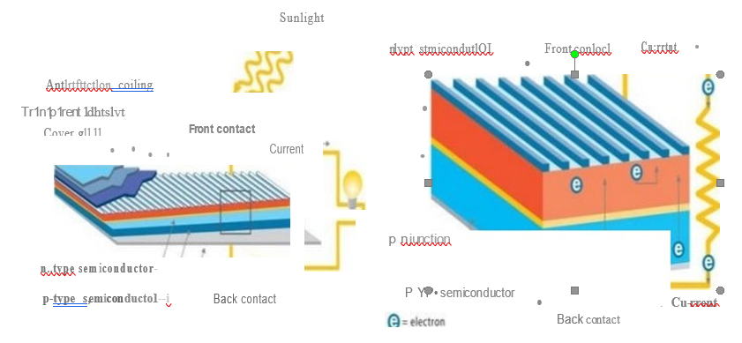

Fig 4.1 Schematic diagram of elemental photovoltaic solar cell

**CHAPTER 5**

**WORKING**

In order to design the best possible flexible solar eel the basic working principles of the cell must first be understood. The n1ethods of light absotption, charge separat ion, and charge transfer 1nust be detetmined to be able to take advantage of all the aspects needed to increase efficiency and flexibility. The 1nethods being used by others in the field will give insight into options that work well ,and ones that do not, and ones that have been explored thoroughly .

The cathode is the conductor closest to the side of the p-type se1niconductor layer, and is usuall y 1nade frotn a tnetal in a grid like pattern, although our cathode is a solid metal film of Au/Pd. Belo\¥ this layer lies the two setniconductor layers. The semiconductors <u-e typically sep<ll'ated into two layers, called n and p type se1niconductors, n standing for negative ru1d p for positive. Usually to obtain the two layers of a semiconductor the 1naterial will need to be doped. There ru·e also 1naterials that act as intrinsic n or p type semiconductors that do not need to be doped. Doping introduces a s1nall an1ount of ru1 alternate ele1nent into the 1na in semicondu ctor material . To n1ake the n type layer of the se1niconductor the element that is introduced into the 1nain structure has 1nore valence electrons to create free electrons and the p type semiconductor layer has less valence electrons, in order to create vacru1cies ("holes") for the free electrons to occupy . These are the layers where the charge is sepru·ated and transported .These layers can consist of a v<u·iety of materials which differ in many of the major types of solar cells that exist today. A comn1on exa1nple is crystalline silicon in which one layer is doped to pro1note chru·ge 1nove1nent and the other layer is doped to becon1e a charge receiver.

The back- contact acts as the anode and finishes off the circu it . The anode layer of thin filtn solru·cells is especially in1po1tant in flexible solru·cells, because it can often be the limiting flexible layer. Two of the primary options ru·e lndiutn Tin Oxide (ITO) ru1d Alu minu tn Doped Zinc Oxide (ZnO-Al).

**CHAPTER 6**

**MANUFACTURING PROCESS**

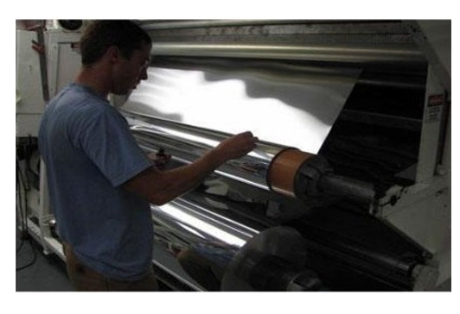

Fig 6.1 Press and printing of semiconductor

The Manufacturing process of the traditional c-Si solar panels are very time-consu1ning and complex and it drives-up the per-watt cost of electricit y. Whereas, the manu facturing of flexible solar cells is con1parat ively easier. A company named Nanosolar produces flexible solar cells by the application of a process nruned, offset printing . It is one kind of print ing techn ique where an inked image is transferred fro111 a plate to a rubber plate , then to the required print ing su1tace. The process followed by the Nanosolar company is 1nore or J ess as described below:.Rean1s of Al (ah11ninu1n) foils co1ne out through very large presses which are similar to those used in newspaper printing. The foils are really Jong in size making the1n 1nuc h more versatile in case of appl ication.

Thin layer of semiconductors is deposited on the alu1ninu1n foil by a printer in an open environme nt. This open environment printing has advantages over the CIGS-on-glass or CdTe cell manufacturing in which the printing is done on a vacuum chan1ber. This vacuu m printing is both expensive and tune consuming. Presses used in this step are very easy to handle and very little of the print ing 1nateria l is wasted which increases the overall efficiency

**CHAPTER 7**

**CLASSIFICATION**

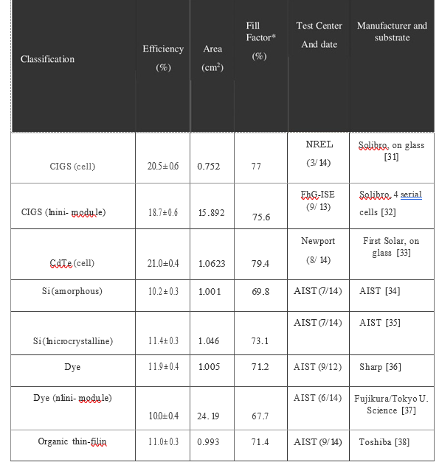

**CHAPTER 8**

**RESEARCH AND DEVELOPMENT**

**8.1 Feather-Light Solar Cells**

The endless possibilities of the flexible solar sector are astound ing. Fro1n large scale embedded PY fabrics to tnicro granular cells, all are withi n otu·grasp.In the recent times, the researchers at MIT have discovered demonstrated solar cells so lightweight and thin , it can stay stable even on a helium balloon. This discovery has led many to believe that efficient yet light solar cells might be possible after all.

The new process is described in a paper by MIT professor Y lad i1nir Bulovic, research scientist Annie Wang, and doctoral student Joel Jean, in the journal Organic Electronics.

The future of solar energy depend s on the innovat ions and applications of new and old technologies. If photovoltaic (PY) devices that turn light into electricity could be mass produced with printing presses and eligible for the mass people, as if they were newspapers or banknot es or any kind of paper or fabric products, they could be affordable and ubiquitous .

**8.2 Solar Fabrics**

The process of tu111ing solar panels into attires has ah·eady started. Several clothing lines have started to market the ir own "Solar Fabr ics". Konarka Technologies produce a thin film poly1ner based PY cell, as a tlexible fihn st itched onto a fabric. The abil it y to 1nake these cells even s1naller is dependent on further research into nano-crystal PY cells. In theory nano-technology could provide a way to expand the range of photons a cell could collect , increasing its efficiency while beco nling smaller. Konarka, in pat1ner Leading Swiss Universit y, is working on this.

The days of silicon based solar cells <n-e ahnost over. They were expensive due to their Convent ional, silicon-based , sol<u- panels are rigid, expe nsive and hard to handle. Smal thin and flexible PY devices on fihns ru-e akead y being 1nade that ru-e lightweig ht and translucent. These material can generate electricit y in low light , even indoors. Integrating the1n into phones and watches , as well as walls and wind ows, would transform the world's energy generation, reduce poll ut ion and near future the solution for global \var1ning.

Now-a-days orgrulic PY cells are up and coming . They ru·e extremely light weight and easi lytnanageable. They do not need special expe11ise to be insta lled or altered. It 's a technology for the 1nass peple.

**CHAPTER 9**

**ADVANTAGES AND DISADVANTAGES**

**9.1 Advantages:**

* The greatest advantage of flexible solar cells is their agilit y factor.
* They are lightweight and can easily fit into spaces where convent iona l solar panels cannot . For instance, if your house fails the roof test for the installation of solar shingles or panels owing to structural issues, you can always opt for ultra-thin flexible solar cells.
* Another advantage of flexible solar panels is that they can be easily attached to unusual places su ch as laptops, mobile phones, cameras, to na1ne a few. A great exai11ple of this is the solar roof of Fisker Kai·ma where the flexible solar panel is integrated pe1fectly to align with the curved roof of the cai'.
* The cost of installi ng tlexible solai·panels is nluch less compared to regulai·solar panels since they requ ire less labor and effort to be installed and being lightweight, they can be easily carried

**9.2 Disadvantages:**

* They are not suitable for large-scale solar projects that require sturdy and more reliable solar panels. The efficiency of these flexible solar panels ranges between **l***l - l 3o/o* which is much less conipared to the effectiveness of n1onocrystalli ne or polycrystallin e panels that have the efficiency range between 14-17%.
* Complex structure
* Need to be very c1u·eful in handling
* Can't be used in astronomical devices.

**CHAPTER 10**

**CONCLUSION**

This stud y showed us that the co1nbi nation of PET, ITO, Sb2S3, CuSCn , and gold/pallad ium is a viable flexible solar cell that should be studied in more depth to increase the efficiency of the cell. Other material options, 1naterial deposit ion processes, and cell designs should also be explored to attempt to create a 1nore resilient solar cell.

To perforn11nany of the processes that were involved in_the creat ion of these cells our group had to work together to plan and schedule. Often with our work there were setbacks in the laboratory that would delay us for days. Other ti1nes when we \Vere 1net with several failures in a ro\v we had to learn to innovate and overcon1e the obstacle we faced. Learning to work with other people outside of our group was also i1nportant , as we relied on the help of graduate students for learning lab practices and for obtaining SEM images. With proper planning and co1nmu nication, \Ve were able to work very well together.

Creating flexible solar cells is an i1nportant step in the future of the energy industry. The applications of solar power will be greatly increased with the advanceme nt and ilnple1nentatio n of flexible solar cells.

**CHAPTER 11**

**REFERNCES**

[l] Choubey, R. K., Desai, D., Kale, S. N ., & Ku1nar, S. (2016). Effect of arinealing treatn1ent and deposition te1nperature on CdS thin fihns for CIGS solar cells applications. Journal of Materials Science: Materials in Electronics, 27(8), 7890-7898 doi:l0.1007/sl0854-016-4780-2.

(2) De Bettign ies, R., Leroy, J., Firon , M., & Sentein, C.(2006). Accelerated lifetime 1neasure 1nents of P3HT:PCBM solarcells. Synthet ic Metals, 156(7-8), 510-513. doi:http://dx .doi.org/l0.1016/j.synt hmet.2005.06.016.

[3] Brabec, C. J ., Gowrisanker, S., Halls, J. J . M., Laird, D., Jia, S., & Williams, S. P. (2010). Poly n1er- Fu llerene Bulk-Heteroju nct ion Solar Cells. Ad vanced Materials, 22(34), 3839-3856. doi:l 0.1002/adma.200903697.

[4] Pineda, E., Nicho , M.E., N air, P. K. , & Hu, H. (2012). Optoelectronic prope1ties of che1nicall y deposited Bi2S3 thin fi!Jns and the photovoltaic petformance of Bi2S3/P30T solarcells. Solar Energy, 86(4), 1017-1022. doi:[http://dx](http://dx/).doi.org/ 10.1016/j.solener.201 1.06.015.

[5]Alnotphous Silicon Solar Panels. (2013). Retrieved from http://www.solar-facts­ andadvice.coin/amorphous-silican.ht1nl

[6]Ellabban, On1ar; Abu-Rub, Haitha1n; Blaabjerg, Frede (2014). "Renewable energy resources: Current status, future prospects and their enabling technology". Renewable and Sustai nable Energy Reviews. 39: 748-764 (749].